**Team Member Info**:

* Ron Raisch:  
  ron.raisch@mail.huji.ac.il | ID: 322657529 | CSE: ronraisch
* Cfir Amar:  
  cfir.amar@mail.huji.ac.il | 207282484 | cfiramar
* Yishay Polatov:  
  polyishay@gmail.com | 316302140 | yishayp

**Problem Description**:

We set out to examine whether financial trends in politically, ethically, or ideologically aligned equities and ETFs reflect shifts in public sentiment, online attention, or major global events. Our goal is to uncover consistent or surprising patterns between Google search interest and asset prices - for both emotionally charged assets and mainstream stocks and indices.

**Data**:

We gathered historical price and volume data (daily frequency, 5+ years) from Yahoo Finance for a wide range of assets: individual stocks (e.g., Google, Apple, Tesla), broad indices (e.g. S&P500), thematic ETFs (e.g., AQWA, ICLN), and symbolically aligned instruments (e.g. pro-Israel, pro-Palestine, pro-Ukraine, green/ESG funds, water equity, gender equity). We also pulled Google Trends data for related keyword searches: geopolitical terms ("pro-Israel", "visit Israel", "support Ukraine"), financial sentiment ("bull market", "beginner finance course"), social themes ("LGBTQ", "LGBTQ law", "women rights"), and corporate events ("new iPhone", "WWDC", "earnings report"). The dataset includes ~13K time-series rows and auxiliary metadata.

**Visualization 1 - Reality Check 1: Israel ETFs**

We expected that pro-Israel ETFs would show increased volume following a spike in relevance (e.g. war, political movement), but found the opposite: from October 7, 2023, there's an **exponential rise** in prices, while volume has **decreased linearly**. This suggests strong core investors buying and holding — a trend driven ideologically rather than speculatively. תמונה שמכילה קו, עלילה, תרשים

תוכן שנוצר על-ידי בינה מלאכותית עשוי להיות שגוי.   
תמונה שמכילה טקסט, צילום מסך, גופן, עלילה

תוכן שנוצר על-ידי בינה מלאכותית עשוי להיות שגוי.

**Visualization 2 - Reality Check 2: Seasonal LGBTQ+ Trendline**

When looking up for LGBTQ-themed ETFs correlation to relevant search terms or legal events, we thought a seasonal trend should be visible. June is known as the Pride Month; thus we thought each June "LGBTQ" will be trending in Google searches. We thought this yearly spike will transfer into investments in LGBTQ-themed ETFs. While the data behaved as expected, we found no correlation between EFTs and google searches.

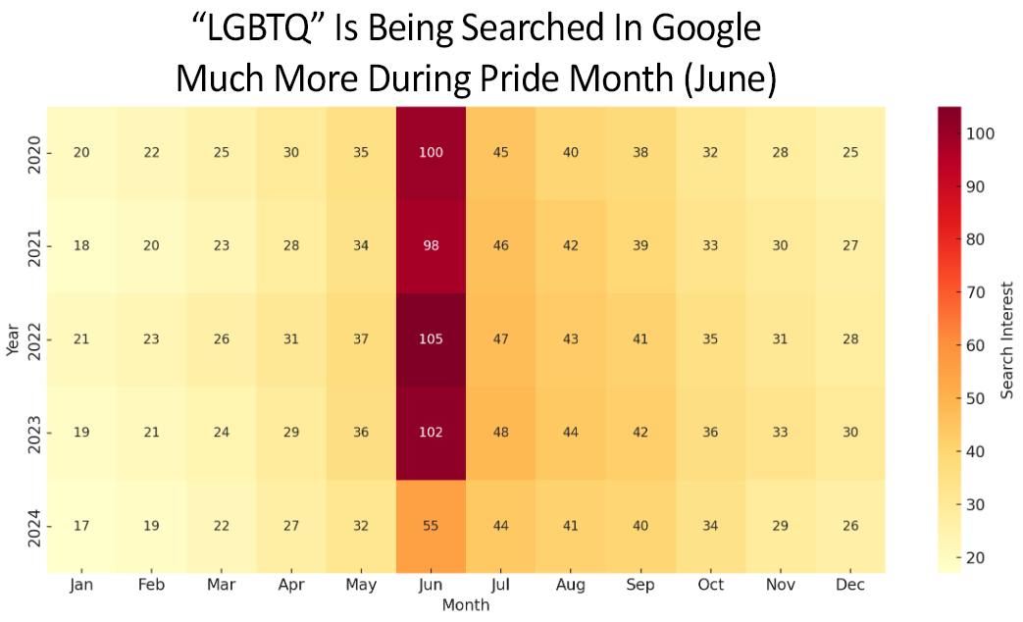

**Visualization 3 - Observation: Apple and the Mid-April Dip**

Analyzing Apple (AAPL) data, we identified that week 16 (mid-April) showed consistent declines in **every year** reviewed. These declines were typically small but strikingly regular. Additionally, weeks in late March tended to underperform more significantly, while week 25 (late June) often showed gains - likely tied to the buzz around Apple’s annual WWDC event. While the June gains may be explained by anticipation surrounding developer announcements, the mid-April dip remains a mystery—possibly linked to Q1 portfolio rebalancing or broader macroeconomic cycles not reflected in search trends.

In the following plot, light-green lines represent June data, while dark-red lines indicate March trends:

Seasonal Patterns in Apple Stock:  
Weakness in March–April, Strength in June

